SUMMER INTERNSHIP REPORT
ON
ELECTRIC VEHICLE DESIGN

A project report
Submitted in partial fulfilment of the requirements for the
award of

BACHELOR OF TECHNOLOGY
in
ELECTRICAL & ELECTRONICS ENGINEERING

By
PULAVARTHI SURESH – 238T5A0211

Under the guidance of Faculty Mentor
Dr. ANANTHASAI SOMASI
Assistant Professor



Dhanekula Institute of Engineering & Technology
( approved by A.I.C.T.E new delhi and Affiliated to JNTU, Kakinada )

GANGURU
2024-2025


Dhanekula Institute of Engineering & Technology
Ganguru, Vijayawada – 521139
AUTONOMOUS
Approved by AICTE New Delhi, Permanently Affiliated to JNTU Kakinada
An ISO 9001-2015 Certified Institution & NBA Accredited _{(EEE, ME, ECE & CSE)}
DEPARTMENT OF ELECTRICAL AND ELECTRONICS ENGINEERING

CERTIFICATE

This is to certify that the SUMMER INTERNSHIP Report work entitled “ELECTRIC VEHICLES(EV) DESIGN” is a Bonafide certificate of Internship work done by PULAVARTHI SURESH – 238T5A0211. B. Tech in the Department of Electrical and electronics engineering of Dhanekula Institute of Engineering & Technology.

Internship Co-Ordinator External Examiner Head of the Department

ACKNOWLEDGEMENT

First and foremost, we sincerely salute our esteemed institution DHANEKULA INSTITUTE OF ENGINEERING AND TECHNOLOGY for giving me this opportunity for fulfilling my summer internship.

We express our sincere thanks to our beloved Principal Dr. Ravi Kadiyala Garu for providing all the library and lab facilities required for completing this summer internship successfully.

We are glad to express my deep sense of gratitude to Head of EEE Department Dr. Guruvulu Naidu Ponnada, Associate Professor, who were abundantly helpful and offered in valuable assistance, support and guidance throughout this summer internship.

We wish to express my gratitude to Dr. Anantha Sai Somasi, Assistant Professor, without whose knowledge and assistance this study would not have been successful. We are glad to express my deep sense of gratitude to all Department faculty who were abundantly helpful and offered in valuable assistance, support and guidance throughout this summer internship.

We thank one and all who have rendered help directly or indirectly in the completion of this summer internship report successfully.

PO’S/PSO’S

List Program Outcomes

- Engineering knowledge: Apply the knowledge of mathematics, science, engineering fundamentals & an engineering specialization to the solution of complex engineering problems.
- Problem Analysis: Identify, formulate, review research literature & analyze complex engineering problems reaching sustained conclusions using first principles of mathematics, natural sciences& engineering sciences.
- Design/Development of Solutions: Design solutions for complex engineering problems and design system components or process that meet the specified needs with appropriate consideration for the public health and safety and the cultural, societal & environmental considerations.
- Conduct Investigations of Complex Problems: Use research-based knowledge and research methods including design of experiments, analysis and interpretation of data, and synthesis of the information to provide valid conclusions.
- Modern Tool Usage: Create, select, and apply appropriate techniques, resources, and modern engineering and IT tools including prediction and modelling to complex engineering activities with an understanding of the limitations.
- The Engineer And Society: apply reasoning informed by the contextual knowledge to assess societal, health, safety, legal and cultural issues and the consequent responsibilities relevant to the professional engineering practice.
- Environment And Sustainability: understand the impact of the professional engineering solutions in societal and environmental contexts, and demonstrate the knowledge of, and need for sustainable development.
- Ethics: Apply ethical principles and commit to professional ethics and responsibilities and norms of the engineering practice.
- Individual And Team Work: function effectively as an individual, and as a member or a leader in diverse teams, and in multidisciplinary settings.
- Communication: communicate effectively on complex engineering activities with the engineering community and with society at large, such as, being able to comprehend and write effective reports and design documentation, make effective presentations, and give and receive clear instructions.
- Project Management & Finance: demonstrate knowledge and understanding of the engineering and management principles and apply these to one’s own work, as a member and leader in a team, to manage projects and in multidisciplinary environments.
- Life- Long Learning: recognize the need for, and have the preparation and ability to engage in independent and life- long learning in broadest context of technological change.

List Program Specific Outcomes

PSO 1: Ability to design solutions for identified problems by using latest engineering tools like MATLAB, Simulink, PSPICE, plc etc.
PSO 2: Able to design and develop the Green Electrical systems.
VISION – MISSION - PEOs

Institute Vision | Pioneering Professional Education through Quality
Institute Mission | Providing Quality Education through state-of-art infrastructure, laboratories and committed staff.  Moulding Students as proficient, competent, and socially responsible engineering personnel with ingenious intellect.  Involving faculty members and students in research and development works for betterment of society.
Department Vision | Emerge as Quality Human Resource Provider for Industry and Societyin the field of Electrical & Electronics Engineering.
Department Mission | Providing Quality Education through State-of-art resources.  To develop innovative, proficient Electrical engineers.  Promoting Ethical and moral values among the students so as to make them responsible professionals for the society.

Certificate

INDEX

Chapter No Title Page No
1 Introduced to Electric Vehicle 1
2 History of Electric Vehicles 4
3 The Working Principle of ElectricVehicles In Detailed 8
4 Different Types of Electric Vehicles andTheir Model Representations 9
5 Several Components of Electric Vehicle 13
6 Advantages of Electric Vehicles 17
7 Disadvantages of Electric Vehicles 19
8 Recent Trends in Electric Vehicles 21
9 Electric Vehicle (Ev) 4-Wheeler Report 23
10 Result 25
References 26

List of Figures

Figure No. Title Page No.
Fig 2.1 A Woman Charging A 1912 Columbia Electric Car 6
Fig 2.2 Electric car built in England by Thomas Parker 6
Fig 4.1.1 BEV Layout 10
Fig 4.2.1 HEV Layout 10
Fig 4.3.1 PHEV Layout 11
Fig 4.4.1 FCEV Layout 12
Fig 5.1 Main Components of EV 13
Fig 8.1 Recent Trends in EV 21

CHAPTER 1

INTRODUCED TO ELECTRIC VEHICLE
Electric vehicles come in several types, including Battery Electric Vehicles (BEVs), which operate solely on electric power; Plug-in Hybrid Electric Vehicles (PHEVs), which combine an electric motor with a conventional engine and can be charged from an external source; and Hybrid Electric Vehicles (HEVs), which use both electricity and fuel but cannot be plugged in for charging. The heart of an EV is its battery pack, most commonly based on lithium-ion technology, which offers high energy density and long cycle life. Charging can be done at different speeds, from slow home charging that may take several hours to ultra-fast charging stations that can replenish a significant portion of the battery in under an hour. The efficiency of EVs is far greater than that of traditional vehicles, as they convert a higher percentage of the electrical energy into movement, while regenerative braking systems capture and reuse energy that would otherwise be lost during braking.
The adoption of electric vehicles is also driving innovations in connected and autonomous technologies. Many modern EVs feature advanced driver assistance systems, smart infotainment platforms, and vehicle-to-grid (V2G) capabilities, allowing them to not only consume electricity but also return it to the grid during peak demand. Furthermore, EVs contribute to reducing urban noise pollution due to their near-silent operation, improving the quality of life in cities. While challenges remain—such as the need for more widespread charging infrastructure, the environmental impact of battery production, and the initial purchase cost—ongoing research and development are steadily addressing these issues. The future of EVs is promising, with next-generation batteries, such as solid-state designs, expected to offer faster charging, longer range, and enhanced safety, further accelerating the shift toward an all-electric transport system.
Electric vehicles (EVs) represent a transformative shift in the global transportation industry, replacing traditional internal combustion engines with electric propulsion systems powered by rechargeable batteries. This change is being driven by environmental concerns, technological advancements, and the urgent need to reduce dependence on fossil fuels. Unlike conventional vehicles that emit harmful gases such as carbon dioxide (CO₂) and nitrogen oxides (NOₓ), EVs produce zero tailpipe emissions, making them an essential solution for combating climate change and improving urban air quality. They operate with remarkable energy efficiency, converting most of the electrical energy stored in their batteries into motion, compared to the relatively low efficiency of petrol or diesel engines. With quiet operation, smooth acceleration, and lower maintenance requirements due to fewer moving parts, EVs deliver both environmental and user-friendly benefits.
The development of electric vehicles is not new; in fact, they date back to the late 19th and early 20th centuries when they briefly competed with steam- and gasoline-powered cars. However, limited battery technology at the time meant short ranges and long charging times, causing EVs to fade from the mainstream as petroleum became widely available. The modern resurgence of EVs began in the late 20th century and accelerated in the 21st century as concerns about global warming, rising fuel prices, and technological breakthroughs in lithium-ion batteries fueled renewed interest. Today, EVs come in several forms, including Battery Electric Vehicles (BEVs) that run entirely on electric power, Plug-in Hybrid Electric Vehicles (PHEVs) that combine an electric motor with a petrol or diesel engine, and Hybrid Electric Vehicles (HEVs) that recharge their batteries through regenerative braking and engine power.
Globally, the EV market is growing at an unprecedented rate, supported by strong government policies, subsidies, and infrastructure investments. Countries such as Norway, China, and the Netherlands have taken the lead in EV adoption through tax incentives, free or discounted tolls, and widespread charging networks. Automakers are investing heavily in EV research and development, producing models with longer ranges, faster charging capabilities, and more affordable prices. In parallel, advancements in charging infrastructure—from home chargers to highspeed public stations—are making EV ownership increasingly convenient. The integration of renewable energy sources, such as solar and wind power, into EV charging systems is further enhancing their environmental benefits, ensuring that the electricity used is as clean as the vehicles themselves.
Looking ahead, the electric vehicle industry is poised to benefit from innovations like solid-state batteries, which promise higher energy density, faster charging, and improved safety over conventional lithium-ion technology. Additionally, vehicle-to-grid (V2G) technology could transform, EVs into mobile energy storage units, capable of supplying power back to the grid during peak demand, thus contributing to energy stability. While challenges remain—such as reducing the environmental footprint of battery production, ensuring adequate raw material supply, and expanding rural charging access—the trajectory of progress is clear. EVs are not just a trend but a cornerstone of the future transportation ecosystem, offering a cleaner, quieter, and more efficient way to travel, and playing a crucial role in the global mission toward a sustainable, low-carbon future.

CHAPTER 2

HISTORY OF ELECTRIC VEHICLES

2.1 Early Invention and 19th-Century Rise:
The history of electric vehicles dates back to the early 19th century, when inventors in different countries began experimenting with battery-powered transportation. In the 1820s and 1830s, pioneers such as Ányos Jedlik in Hungary, Robert Anderson in Scotland, and Thomas Davenport in the United States created some of the first small-scale electric motors and vehicles. By the late 1800s, improvements in lead-acid battery technology allowed electric carriages to travel short distances without manual effort. In the 1880s and 1890s, EVs became increasingly popular in urban areas, especially in the United States and Europe, because they were quieter, cleaner, and easier to operate compared to steam- or gasoline-powered vehicles.

2.2 The Golden Age of EVs (Late 1800s – Early 1900s):
By the turn of the 20th century, electric vehicles were competing strongly with gasoline and steam- powered cars. In the United States around 1900, nearly onethird of all vehicles on the road were electric. They were especially popular among wealthy urban residents, as they required no hand- cranking, produced no unpleasant exhaust fumes, and were well-suited for short city trips. Notable companies like Baker Electric, Detroit Electric, and Columbia Automobile Company produced elegant electric cars, and famous figures such as Thomas Edison worked on improving their batteries. Women drivers, in particular, favored EVs for their ease of operation and reliability.

2.3 Decline Due to Gasoline Dominance (1910s – 1930s):
The success of the electric vehicle was short-lived. By the 1910s, several key developments led to the decline of EVs. Henry Ford’s introduction of the massproduced Model T in 1908 drastically reduced the cost of gasoline cars, making them affordable for the general public. The invention of the electric starter in 1912 eliminated the need for manual cranking, removing one of the main advantages of EVs. In addition, the discovery of vast petroleum reserves, along with the construction of better roads that encouraged long-distance travel, favored gasolinepowered cars that could travel farther and refuel quickly. By the 1930s, electric vehicles had almost completely disappeared from the mainstream market.

2.4 Dormant Period and Limited Use (1930s – 1980s):
For much of the mid-20th century, electric vehicles were relegated to niche applications such as forklifts, golf carts, and small delivery trucks. Efforts to reintroduce electric passenger cars were rare and often unsuccessful due to the limitations of battery technology, which resulted in low range and slow speeds. Interest in EVs briefly resurfaced during the oil crises of the 1970s, when fuel shortages and rising prices sparked concern about dependence on foreign oil. However, he technology of the time could not compete with gasoline vehicles in terms of performance and convenience, and EV adoption remained minimal.

2.5 Modern Revival and 21st-Century Growth:
The real revival of electric vehicles began in the late 20th and early 21st centuries, driven by environmental concerns, advances in battery technology, and government regulations on emissions. In the 1990s, models like the General Motors EV1 demonstrated the potential of modern EVs, even though they were discontinued due to high costs and limited demand. The launch of the Tesla Roadster in 2008, powered by lithium-ion batteries, proved that electric cars could be fast, stylish, and practical. Since then, major automakers have invested heavily in EV development, producing models with longer ranges, faster charging, and more affordable prices. Today, electric vehicles are seen as a key part of the solution to climate change, with global sales growing rapidly and governments worldwide setting ambitious targets for a transition away from fossil fuel-powered transport.

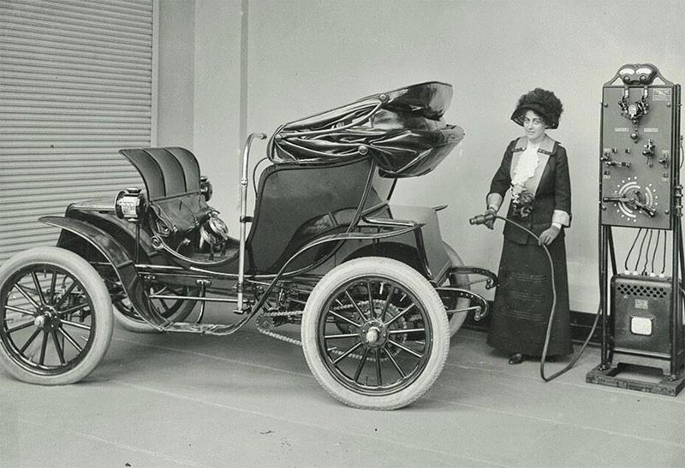
Fig 2.1 A Woman Charging A 1912 Columbia Electric Car

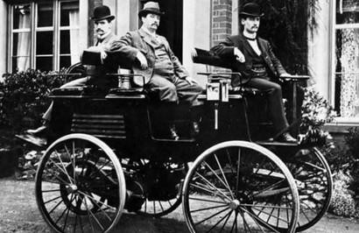
Fig 2.2 Electric car built in England by Thomas Parker

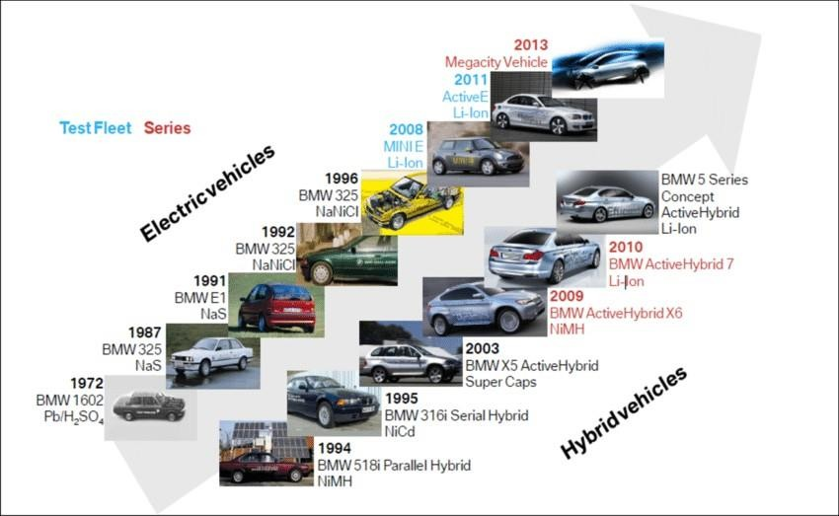
Fig 2.3 Timeline of Development of Electric Vehicle

CHAPTER 3

THE WORKING PRINCIPLE OF ELECTRIC VEHICLES IN DETAILED

The working principle of an electric vehicle (EV) is based on converting stored electrical energy into mechanical energy to drive the wheels, eliminating the need for internal combustion. EVs use a high- capacity rechargeable battery pack, usually lithium-ion, as the primary energy source. When the driver presses the accelerator pedal, a controller regulates the flow of electrical power from the battery to the electric motor according to the required speed and torque. This process is silent, smooth, and highly efficient, as electric motors can deliver maximum torque instantly without the delays typical of fuel-powered engines.
The electric motor in an EV operates on the principle of electromagnetic induction or permanent magnetism, depending on the motor type. When electric current flows through the motor’s windings, it generates a magnetic field that interacts with magnets or coils, creating rotational force (torque) on the rotor. This rotation is transmitted directly or through a simple gear reduction system to the wheels, propelling the vehicle forward. The simplicity of the design means fewer moving parts than in conventional vehicles, reducing maintenance needs.

EVs also employ regenerative braking to improve efficiency. When the driver applies the brakes or releases the accelerator, the motor reverses its role, acting as a generator that converts kinetic energy back into electrical energy, which is stored in the battery for later use. This not only extends driving range but also reduces wear on traditional braking components. Overall, the working principle of an EV centers on efficient energy conversion, precise control through electronics, and the recycling of energy during operation.

CHAPTER 4

DIFFERENT TYPES OF ELECTRIC VEHICLES AND THEIR MODEL REPRESENTATIONS

Electric vehicles (EVs) can be broadly classified into four main types based on their power source, energy storage, and the role of the electric motor in propulsion.Each type has its own operating characteristics and applications.
- Battery Electric Vehicle (BEV)
- Hybrid Electric Vehicle (HEV)
- Plug-in Hybrid Electric Vehicle (PHEV)
- Fuel Cell Electric Vehicle (FCEV)
4.1 Battery Electric Vehicle (BEV):
A Battery Electric Vehicle (BEV), also called All-Electric Vehicle (AEV), runs entirely on a battery and electric drive train. This types of electric cars do not have an ICE.
Electricity is stored in a large battery pack that is charged by plugging into the electricity grid. The battery pack, in turn, provides power to one or more electric motors to run the electric car.
Examples of BEV:
Volkswagen e-Golf, Tesla Model 3, BMW i3, Chevy Bolt
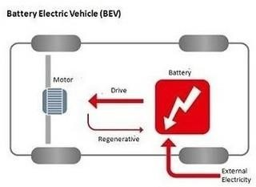
Fig 4.1.1 BEV Layout

4.2 Hybrid Electric Vehicle (PHEV):
This type of hybrid cars is often called as standard hybrid or paralel hybrid. HEV has both an ICE and an electric motor. In this types of electric cars, internal combustion engine gets energy from fuel (gasoline and others type of fuels), while the motor gets electricity from batteries. The gasoline engine and electric motor simultaneously rotate the transmission, which drives the wheels.
Examples of HEV: Honda Civic Hybrid, Toyota Prius Hybrid, Honda Civic Hybrid
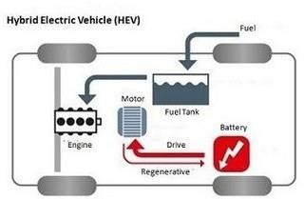
Fig 4.2.1 HEV Layout

4.3 Plug-in Hybrid Electric Vehicle (PHEV)
PHEV is a type of hybrid vehicle that both an ICE and a motor, often called as series hybrid. This types of electric cars offers a choice of fuels. This type of electric cars is powered by a conventional fuel (such as gasoline) or an alternative fuel (such bio- diesel) and by a rechargeable battery pack. The battery can be charged up with electricity by plugging into an electrical outlet or electric vehicle charging station (EVCS).
Examples of PHEV: Porsche Cayenne S E-Hybrid , Chevy Volt, Chrysler Pacifica
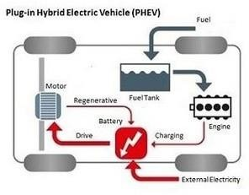
Fig 4.3.1 PHEV Layout

4.4 Fuel Cell Electric Vehicle (FCEV):
Fuel Cell Electric Vehicles (FCEVs), also known as fuel cell vehicles (FCVs) or Zero
Emission Vehicle, are types of electric cars that employ ‘fuel cell technology’ to generate the electricity required to run the vehicle. In this type of vehicles, the chemical energy of the fuel is converted directly into electric energy.
Examples of FCEV:
Toyota Mirai, Hyundai Tucson FCEV, Riversimple Rasa, Honda Clarity Fuel Cell
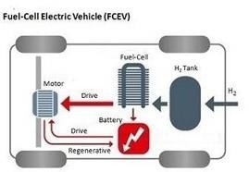

Fig 4.4.1 FCEV Layout

CHAPTER 5

SEVERAL COMPONENTS OF ELECTRIC VEHICLE
Electrical vehicle have several key components that work in harmony to propel the vehicle using electrical energy.
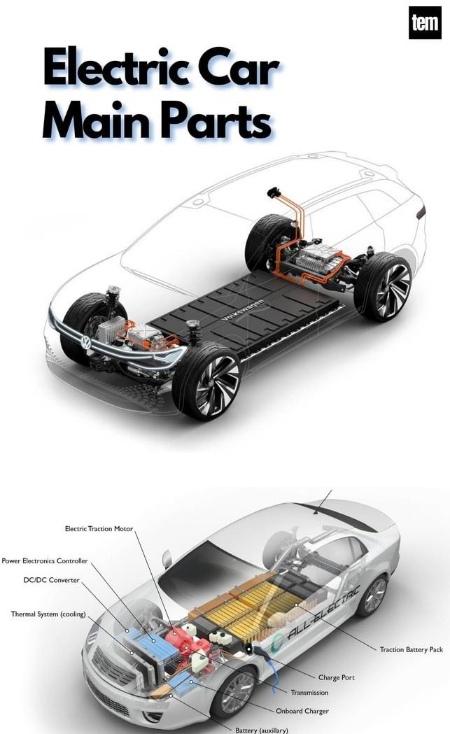

Fig 5.1 Components of EV
Here’s a detailed explanation of the main components of an electric vehicle (EV) and their roles in operation
5.1 Battery Pack:
Function: The battery pack is the main energy storage unit of an EV, supplying power to the electric motor and other vehicle electronics.
Details:
Most EVs use lithium-ion batteries due to their high energy density, long cycle life, and low self- discharge.
The battery pack consists of many smaller battery cells arranged into modules for efficiency and safety.
Key parameters: Capacity (kWh), voltage, weight, and cooling system.
Example: A Tesla Model S has battery packs ranging from ~75 kWh to 100 kWh.

5.2 Electric Motor
Function: Converts electrical energy from the battery into mechanical energy to drive the wheels.
Types of Motors:
- Permanent Magnet Synchronous Motor (PMSM) – High efficiency, used in Tesla Model 3.
- Induction Motor (IM) – Robust, used in Tesla Model S and X.
- Switched Reluctance Motor (SRM) – Durable, used in some commercial EVs.
Operation Principle: Works on electromagnetic induction or attraction/repulsion of magnetic fields.

5.3 Power Electronics Controller
Function: Regulates the flow of electrical energy between the battery and the motor based on driver input.
Details:
- Controls motor speed, torque, and direction (forward/reverse).
- Converts DC from the battery to AC for AC motors (via an inverter).
- Protects components from overcurrent or overheating.
5.4 Transmission (Gearbox)
Function: Transfers torque from the motor to the wheels.
Details:
- Most EVs use a single-speed transmission because electric motors provide a wide torque range.
- Some performance Evs may use a two-speed gearbox for efficiency at high speeds.
5.5 Onboard Charger (OBC)
Function: Converts AC power from a charging station or wall outlet into DC to recharge the battery.
Details:
- Manages charging speed and battery safety.
- Works with Battery Management System (BMS) to optimize charging.

5.6 Battery Management System (BMS)
Function: Monitors and controls the battery pack’s operation.
Details:
- Tracks state of charge (SoC), state of health (SoH), temperature, and voltage of each cell.
- Balances cells to prevent overcharging or deep discharge.
- Ensures safety against overheating or short circuits.

5.7 Regenerative Braking System:
Function: Recovers kinetic energy during braking and converts it into electrical energy stored back in the battery.
Details:
- Reduces wear on mechanical brakes • Improves driving range and efficiency.
5.8 Thermal Management System:
Function: Keeps the battery, motor, and electronics within safe temperature limits.
Details:
- Uses liquid cooling, air cooling, or refrigerant-based systems.
- Critical for battery lifespan and motor efficiency.
  - Auxiliary Systems:
Function: Support vehicle operation and comfort.
Examples: Lighting, infotainment, climate control (HVAC), power steering, and sensors for autonomous driving.
  - Charging Port:
Function: Interface for connecting the EV to a charging source.
Details:
- Different standards include Type 1, Type 2, CCS, CHAdeMO, and Tesla
Supercharger.
- Supports AC slow charging and DC fast charging.

CHAPTER 6

ADVANTAGES OF ELECTRIC VEHICLES

Here’s a detailed explanation of the major advantages of electric vehicles (EVs), covering environmental, economic, and performance perspectives:
6.1 Environmental Benefits:
Zero Tailpipe Emissions:
EVs produce no exhaust gases like CO₂, NOx, or particulate matter during operation, helping reduce urban air pollution.
This is particularly important in cities where vehicle emissions contribute heavily to smog and respiratory illnesses.

6.2 Reduced Greenhouse Gas Emissions:
Even when charged from a power grid that includes fossil fuels, EVs generally emit less CO₂ over their lifetime compared to internal combustion engine (ICE) vehicles.
When charged using renewable sources (solar, wind, hydro), they become nearly carbon-neutral in operation.
6.3 Lower Operating Costs:
Cheaper "Fuel":
Electricity is generally less expensive than petrol or diesel per kilometer driven.
For example, charging an EV might cost ₹1–₹2 per km in India, whereas petrol can cost ₹6–₹8 per km.
6.4 Low Maintenance Needs:
EVs have fewer moving parts compared to ICE vehicles—no engine oil, spark plugs, fuel filters, or exhaust systems.
Regenerative braking reduces wear on brake pads, further lowering maintenance costs.

6.5 Energy Efficiency::
Electric motors convert 85–90% of electrical energy into mechanical energy, while petrol engines typically convert only 20–30%.
Less energy is wasted as heat, making EVs more efficient in real-world use.

6.6 Performance Benefits:
Electric motors deliver maximum torque instantly, providing quick and responsive acceleration without gear shifts.
Many EVs outperform similar-sized petrol cars in acceleration tests.

6.7 Regenerative Braking:
Converts kinetic energy during braking into stored electrical energy, improving efficiency and extending driving range.
6.8 Energy Independence and Renewable Integration:
EVs can be charged from home solar panels or renewable grids, reducing dependence on imported fossil fuels.
Can help stabilize power grids by acting as energy storage through vehicle-togrid (V2G) technology.
6.9 Government Incentives and Benefits:
Many governments offer tax benefits, purchase subsidies, reduced registration fees, and even toll exemptions for EV owners.
In India, schemes like FAME-II provide financial support to lower EV costs.

6.10 Future-Proof Technology:
EVs are aligned with global moves toward sustainable transportation and stricter emission norms.
Automakers are continuously improving battery technology, range, and charging speed, making EVs increasingly practical.

CHAPTER 7

DISADVANTAGES OF ELECTRIC VEHICLES

Here’s a detailed explanation of the disadvantages of electric vehicles (EVs), covering technical, economic, and practical limitations

7.1 Limited Driving Range:
Current Situation:Most affordable EVs have a range of 200–400 km on a single charge, which may be sufficient for city use but can cause “range anxiety” during long-distance travel.
Comparison:Petrol/diesel cars can typically travel 500–800 km on a full tank.
Reason:Battery energy density is still lower than the energy density of liquid fuels.

7.2 Long Charging Time:
Slow Charging:Using a regular home outlet (AC charging), it can take 6–12 hours to fully charge.
Fast Charging:Even with DC fast chargers, it often takes 30–60 minutes to reach 80% charge— still longer than refueling a petrol car (2–5 minutes).
Impact:Inconvenient for drivers on long trips or in emergencies.

7.3 High Initial Purchase Cost :
Reason: Lithium-ion batteries are expensive, accounting for 30–40% of the vehicle’s cost.
Impact:Even though running costs are low, the high upfront cost can discourage buyers.
Example:An EV in the same category can cost ₹2–5 lakhs more than its petrol equivalent in India.
7.4 Limited Charging Infrastructure:
Urban vs Rural Gap:Major cities are improving EV charging infrastructure, but rural areas still have very few charging stations.
Impact:Makes long-distance travel less convenient and can cause uncertainty for drivers.

7.5 Battery Degradation:
Effect:Over time, battery capacity decreases, reducing range and performance.
Causes:High charging rates, extreme temperatures, and repeated deep discharges.
Replacement Cost:A new battery pack can cost ₹2–6 lakhs depending on size and technology.

7.6 Heavy Weight:
Reason:Large battery packs can weigh hundreds of kilograms, increasing the vehicle’s overall weight.
Impact:May affect handling, braking, and tire wear, although low center of gravity helps stability.

7.7 Environmental Concerns in Manufacturing:
Battery Production:Mining lithium, cobalt, and nickel can cause environmental damage and raise ethical issues.
Electricity Source:If the grid is powered mostly by coal, EVs indirectly cause significant emissions during charging.

7.8 Towing and Heavy-Duty Limitations:
EVs designed for personal transport may struggle with heavy towing loads compared to diesel vehicles.
High load conditions can drain the battery quickly.

CHAPTER 8

RECENT TRENDS IN ELECTRIC VEHICLES

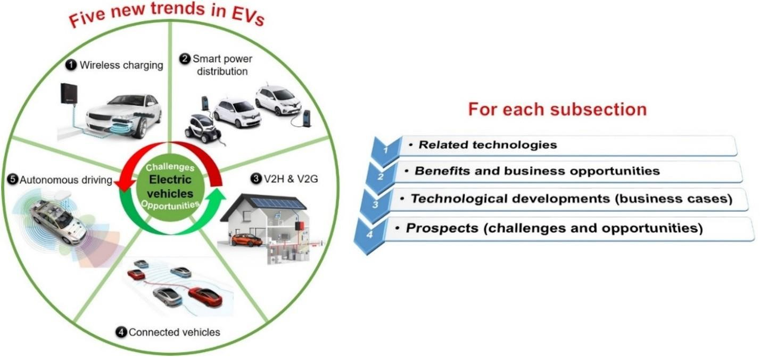

Fig 8.1 Recent Trends in EV
8.1 Solid-State Battery Development:
Solid-state batteries are the future of EV energy storage—offering longer range, faster charging, and improved safety.
Toyota is developing EVs with solid-state batteries offering over
1,000 km range and 10-minute charging. Mass production targeted by 2027.
Nissan and QuantumScape are also actively testing solid-state cells.
8.2 Ultra-Fast and Smart Charging Networks:
Expansion of 350 kW ultra-fast chargers and smart home chargers with scheduling and solar integration.
Tata Harrier EV (India) supports 120 kW DC charging, delivering 80% charge in \~30 minutes.
Kia EV6 supports 800V architecture, charging 10–80% in under 18 minutes.

8.3 Vehicle-to-Grid (V2G) & Vehicle-to-Home (V2H) Integration:
EVs can now power your house or feed energy back into the grid, reducing electricity bills and boosting grid reliability.
Ford F-150 Lightning can power a house for up to 3 days.
Tata Harrier EV and Mahindra XUV.e9 offer V2L (Vehicle-to-Load) support in India for portable appliances.
8.4 AI & Autonomous Tech in Evs:
- EVs are becoming smarter, using AI for route optimization, selfdiagnostics, and driver assistance.
- Volvo ES90 (2025) uses dual Nvidia Orin chips for advanced autonomous features.
- Mahindra XUV.e9 features Level 2 ADAS, predictive driving analytics, and AI voice controls.

CHAPTER 9

ELECTRIC VEHICLE (EV) 4-WHEELER REPORT
During this summer internship, we worked on the design, assembly, and testing of an electric 4- wheeler. The primary objective of the project was to gain practical exposure to electric vehicle (EV) technology, study its core components, and build a working model capable of operating on both solar power and grid charging. Electric vehicles are emerging as an alternative to conventional fuel-based transport by using electricity as their primary energy source, which helps reduce running costs, maintenance needs, and environmental impact.
9.1 System Design and Components:
Our electric 4-wheeler is powered by a 48V, 60Ah lithium-ion battery that serves as the main energy storage unit. The drive system uses a 48V, 60A BLDC motor, providing smooth, quiet operation with high torque efficiency. Renewable charging capability is integrated through a 12V, 40W solar panel, which can fully charge the battery in approximately 18 hours under optimal sunlight. For faster charging, the vehicle can be connected to the grid via an adapter, requiring around 6 hours to complete a charge.
The system also includes key control and safety components such as a PI controller, a 48V-to- 12V voltage regulator for auxiliary devices, a charge controller for battery management, MCB protection to prevent overloads, and an LED display to show real-time speed and battery status.
9.2Performance and Operation:
In our testing, the electric 4-wheeler achieved a running distance of up to 60 km on a full charge without load and 40–60 km with load, depending on road conditions and terrain. The vehicle can carry a maximum load of 500–600 kg. The direct-drive system eliminates the need for a mechanical gearbox, which reduces maintenance and mechanical losses.
The LED dashboard proved useful for monitoring speed and battery levels, while the dual charging system offered flexibility in energy sourcing. Solar charging provides complete independence from the grid, whereas grid charging ensures quick readiness when required.
9.3 Key Learnings and Benefits:
Through this project, we learned how to integrate multiple electrical and mechanical components into a functional vehicle system. We gained practical skills in wiring, controller configuration, battery management, and performance evaluation. The design promotes sustainability by combining renewable solar energy with conventional charging methods, making the vehicle adaptable to varied usage conditions..

CHAPTER 10

RESULT

Through this internship, we gained a clear understanding of the differences between conventional and non-conventional vehicles. Conventional internal combustion engine (ICE) vehicles, while widely used and supported by an established fuel network, rely on fossil fuels and contribute to environmental pollution. In contrast, non-conventional vehicles, such as electric vehicles, operate using cleaner energy sources like electricity or renewables, resulting in zero tailpipe emissions, lower operating costs, and reduced dependence on nonrenewable resources.
By working on the electric 4-wheeler project, we applied this understanding to a practical application. Our vehicle was powered by a 48V, 60Ah lithium-ion battery and driven by a 48V, 60A BLDC motor, ensuring efficient performance. The system allowed dual charging through a 12V, 40W solar panel with an approximate charging time of 18 hours and grid charging capability that completed in about 6 hours.
In testing, the 4-wheeler achieved an uptime of up to 60 km on a full charge without load and 40–60 km with load, depending on terrain and operating conditions. The maximum load capacity reached 500–600 kg, and the vehicle dimensions of 9 ft × 4 ft × 6 ft provided a stable and practical platform for transport. These results validated that a well-designed non-conventional system can deliver reliable performance for short to medium range applications while maintaining energy efficiency and environmental benefits.

References:
- Iqbal Husain. (2021) “Electric and Hybrid Vehicles: Design Fundamentals” .
CRC Press.
- Chris Mi, M. Abul Masrur, and David Wenzhong Gao. (2011) “Hybrid Electric Vehicles: Principles and Applications with Practical Perspectives” . John Wiley & Sons.
- C. C. Chan and K. T. Chau .(2001) ”Modern Electric Vehicle Technology”.
OXford University Press.
- A.K. Babu. (2022) “Electric & Hybrid Vehicles”. Khanna Publishing.

